**Project Team 12 - Electricity Billing System**

Team Members:

1. Anchal Atlani
2. Anushka Kamalapurkar
3. Sagar Kulkarni
4. Gaurav Mahadik

**Context:**

The Electricity Billing System will give a single platform to customers through which they can pay and view their bills of any service provider listed in the system

**Objective:**

The main objective of the project is to develop a database system that will help a customer to register under a service provider, view and pay electricity bill. Apart from this a customer can also change service provider, upgrade to use solar net metering, view historic payments, peak and off peak hours and billing cycle.

**Scope:**

1. **Customer Registration**: Customer register under the system under a specific service provider for smart meter or solar net meter.
2. **View and Pay bills**:
3. Customer can pay and view historic bills.
4. Customer can check the unit consumption of the selected period.
5. Customer can view the off peak and peak hours for the area.
6. **Stop or Change the connection**: Customer can switch to other service provider and customer can deregister from the system.
7. **Admin can add Service Provider/ Customer:** Admin can add any new service provider or new customer.
8. **Admin modify the tariff rates:**

a. Admin can modify the tariff rates of any service provider.

b. Admin can modify the peak and off peak hours corresponding to any service provider in any area.

## **ENVIRONMENT SETUP:**

We are using MySQL Database management System. For making connection to MySQL server we are using mysql-workbench-community-8.0.12-winx64 client. For user interface and database connectivity we are using javax.swing api and jdbc.odbc 7.0 version. We will use Java 8 for our project.

## **HIGH LEVEL REQUIREMENTS:**

**Initial User Roles:**

|  |  |
| --- | --- |
| **Role** | **Description** |
| Customer | New customer can register under a service provider for the electricity billing system. Existing customer can view and pay electricity bills, change service provider, can see unit consumption, can see peak and off peak hours for any specific area. |
| Admin | System admin who can modify the tariff rate, Register/Deregister a customer, Register/Deregister a Service Provider. |

### **Initial user story descriptions:**

|  |  |
| --- | --- |
| **Story ID** | **Story Description** |
| US1 | As a customer I want to register under a service provider. |
| US2 | As a registered customer I want to view bill of any selected month. |
| US3 | As a registered customer I want to pay the bills. |
| US4 | As a customer I want to view the tariff rates of any area offered by various service providers already listed. |
| US5 | As a customer I want to change a service provider. |
| US6 | As a customer I want to deregister. |
| US7 | As an admin I want to change the tariff rates of service provider. |
| US8 | As an admin I want to add a customer in the electricity billing system. |
| US9 | As an admin I want to remove a customer from the electricity billing system. |
| US10 | As an admin I want to add a service provider. |

**High level conceptual design:**

**Entities:**

Customer

Admin

Service_Provider

Electricity_Bill

Tariff_Details

**Relationships:**

Customer has connection under a single Service_Provider.

Customer pays Electricity_Bill.

Customer changes a Service_Provider.

Admin updates Tariff_Details.

Service_Provider maintains area specific Tariff_Details.

# **Sprint 1**

## ***REQUIREMENTS:***

|  |  |
| --- | --- |
| **Story ID** | **Story Description** |
| US1 | As a customer I want to register under a service provider. |
| US2 | As a customer I want to login into the system. |
| US3 | As a registered customer I want to view all electricity bills. |
| US4 | As an admin I want to view all registered customers. |
| US5 | As a customer I want to view number of units consumed. |
| US6 | As a registered customer I want to view bill of any selected month. |
| US7 | As a registered customer I want to pay the bills. |
| US8 | As a customer I want to view the tariff rates of any area offered by various service providers already listed. |
| US9 | As a customer I want to change a service provider. |
| US10 | As a customer I want to deregister. |
| US11 | As an admin I want to change the tariff rates of service provider. |
| US12 | As an admin I want to add a customer in the electricity billing system. |
| US13 | As an admin I want to remove a customer from the electricity billing system. |
| US14 | As an admin I want to add a service provider. |

## 

## ***CONCEPTUAL DESIGN***

Entity:**Customer**

Attributes:

customer_id

login_email_id

login_password

ssn

name[composite]

first_name

last_name

address[composite]

address_line_1

address_line_2

city

state

zipcode

phone_number[multivalued]

service_provider_name

register_date

meter_type

customer_id- this customer id is generated whenever a user registers under a service provider.

Entity: **Electricity_Billing_Details**

Attributes:

electricity_bill_id

bill_generated_date

bill_due_date

billing_cycle_start_date

number_of_billing_days

payment_amount

amount_due

last_meter_reading

present_meter_reading

Note:

last_meter_reading and present_meter_reading are in kWH

Entity: **Admin**

Attributes:

login_id[Email id of Admin]

login_password

name[composite]

first_name

last_name

address[composite]

address_line_1

address_line_2

city

state

zipcode

phone_no[multivalued]

Relationship: **Customer** has **Electricity_Billing_Details**

Cardinality: One to Many

Participation:

Customer has partial participation

Electricity_Billing_Details have total participation

***LOGICAL DESIGN***

Table: **Customer**

Columns:

customer_id

login_email_id

login_password

ssn

first_name

last_name

address_line_1

address_line_2

city

state

country

zipcode

phone_number_primary

phone_number_secondary

service_provider_name

register_date

meter_type

Table: **Electricity_Billing_Details**

Columns:

electricity_bill_id

customer_id [foreign key;references customer_id of Customer table]

bill_generated_date

bill_due_date

billing_cycle_start_date

number_of_billing_days

payment_amount

amount_due

last_meter_reading

present_meter_reading

Note:

last_meter_reading and present_meter_reading are in kWH

Table: **Admin**

Columns:

login_id[Email id of Admin]

login_password

first_name

last_name

address_line_1

address_line_2

city

state

zipcode

phone_no_primary

phone_no_secondary

**Queries:**

1. SELECT * FROM Customer;

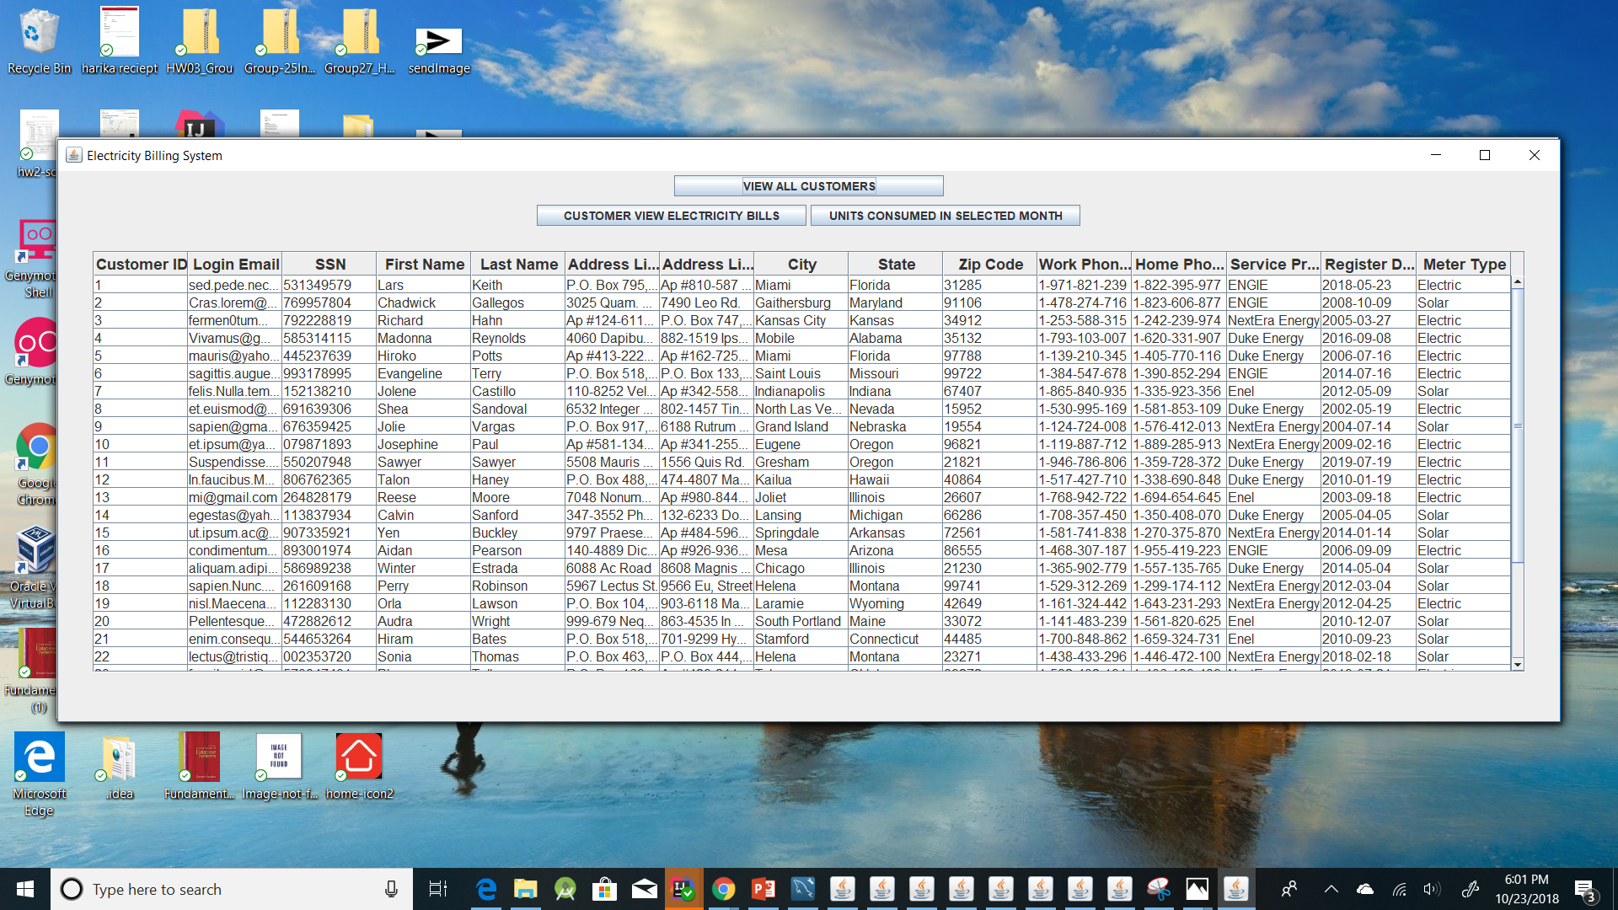

2. SELECT * FROM Electricity_Billing_Details where customer_id=1;

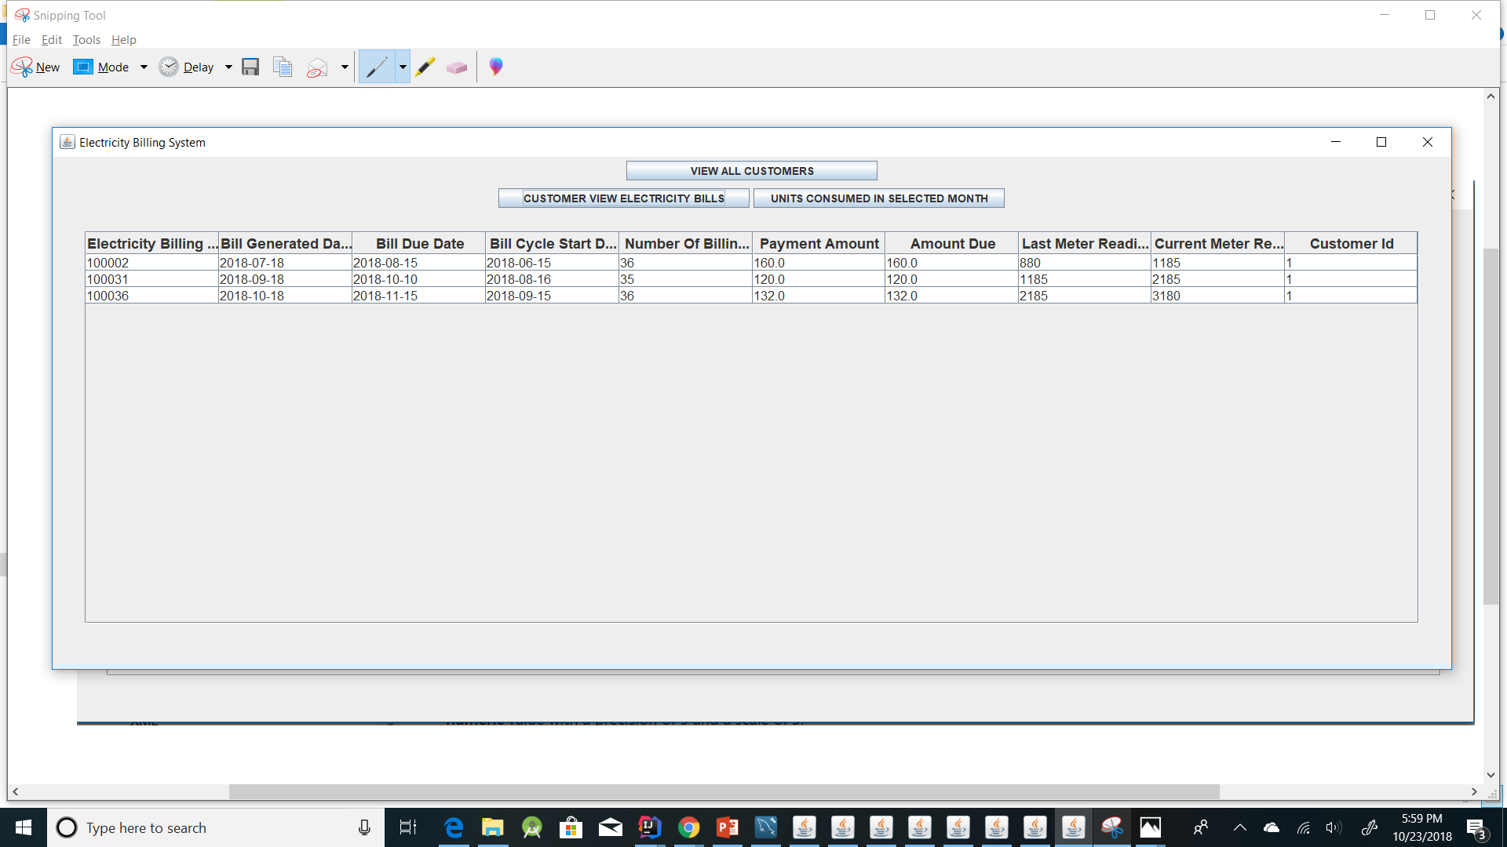

3.

SELECT Electricity_Billing_Details.customer_id, Electricity_Billing_Details.electricity_bill_id, Electricity_Billing_Details.billing_cycle_start_date, last_meter_reading, Electricity_Billing_Details.present_meter_reading, Electricity_Billing_Details.number_of_billing_days, (Electricity_Billing_Details.present_meter_reading-Electricity_Billing_Details.last_meter_reading) as Units_Consumed FROM Electricity_Billing_Details where customer_id=1 AND MONTH(billing_cycle_start_date)=9 AND YEAR(billing_cycle_start_date)=2018;

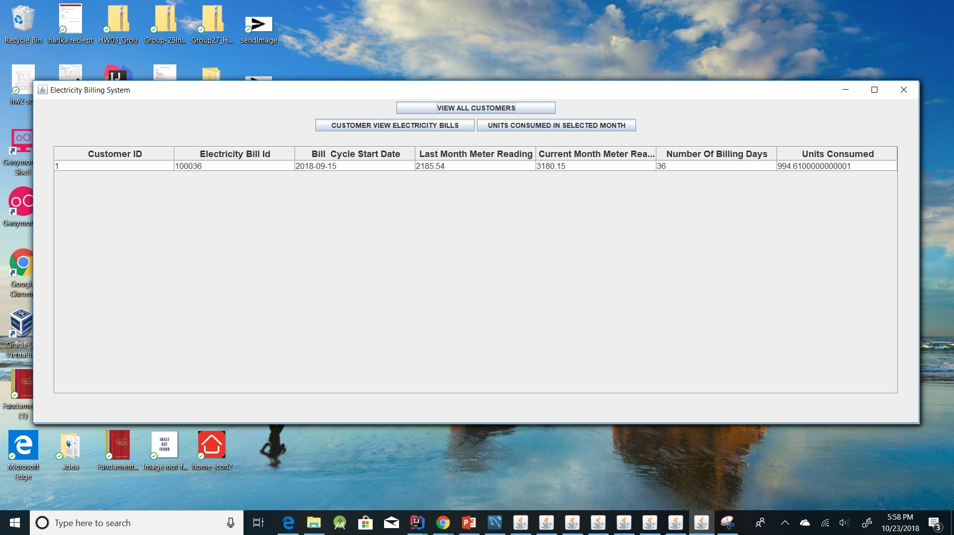

**Sprint 2**

### **Part 1: Refine requirements:**

|  |  |
| --- | --- |
| **Story ID** | **Story Description** |
| US1 | As a customer I want to register under a service provider. |
| US2 | As a customer I want to login into the system. |
| US3 | As a registered customer I want to view all electricity bills. |
| US4 | As an admin I want to view all registered customers. |
| US5 | As a customer I want to view number of units consumed. |
| US6 | As a registered customer I want to view bill of any selected month. |
| US7 | As a customer I want to view the tariff rates of any area offered by various service providers already listed. |
| US8 | As a customer I want to change a service provider. |
| US9 | As a customer I want to deregister. |
| US10 | As an admin I want to change the tariff rates of service provider. |
| US11 | As an admin I want to add a customer in the electricity billing system. |
| US12 | As an admin I want to remove a customer from the electricity billing system. |
| US13 | As an admin I want to add a service provider. |
| US14 | As a registered customer I want to pay the bills. |

### 

### 

### **Part 2: Conceptual design**

Entity: **Customer**

Attributes:

customer_id

login_email_id

login_password

ssn

name[composite]

first_name

last_name

address[composite]

address_line_1

address_line_2

zipcode

state

city

phone_number[multivalued]

service_provider_name

register_date

meter_type

Entity: **Electricity_Billing_Details**

Attributes:

electricity_bill_id

bill_generated_date

bill_due_date

billing_cycle_start_date

number_of_billing_days

payment_amount

amount_due

Entity: **Admin**

Attributes:

login_id[Email id of Admin]

login_password

employee_number

name[composite]

first_name

last_name

address[composite]

address_line_1

address_line_2

zipcode

state

city

phone_no[multivalued]

Entity: **Service_Provider**

Attributes:

service_provider_name

license_number

license_expiry

address[composite]

address_line_1

address_line_2

zipcode

state

city

head_office_number

helpline_number

Entity: **Tariff_Details**

Attributes:

zip_code

provider_name

state

city

peak_time_charge

off_peak_charge

peak_time

off_peak_time

Entity: **Meter_Reading**

Attribute:

meter_number

peak_hour_reading

off_peak_hour_reading

meter_reading_date

total_current_reading

total_previous_reading

Relationship: **Customer** has **Meter_Reading**

Cardinality: One to Many

Participation:

Customer has partial participation

Meter_Readinghave total participation

Relationship: **Meter_Reading** generates **Electricity_Billing_Details**

Cardinality: One to One

Participation:

Customer has partial participation

Meter_Readinghave total participation

Relationship: **Service_Provider** has **Tariff_Details**

Cardinality: One to many

Participation:

Service_Provider has partial Participation

Tariff_Details have partial Participation

Relationship: **Customer** views **Tariff_Details**

Cardinality: Many to Many

Participation:

Customer has partial participation

Tariff_Details have partial_participation

Relationship: **Admin** adds **Customer**

Cardinality: One to Many

Participation:

Admin has partial Participation

Customer has total participation

### **Part 3: Logical design**

Table: **Customer**

Columns:

customer_id

login_email_id

login_password

ssn

first_name

last_name

address_line_1

address_line_2

zip_code [foreign key; references zip_code of ZipCode_Details Table]

phone_number_primary

phone_number_secondary

service_provider_name

register_date

meter_type

**Primary Key Justification**: customer_id of each customer will be unique, and it will be assign during registration of customer in system.

**Normal form:**

Highest normalization level:4NF

Table: **Admin**

Columns:

employee_id

login_id[Email id of Admin]

login_password

first_name

last_name

address_line_1

address_line_2

zip_code [foreign key; references zip_code of ZipCode_Details Table]

phone_no_primary

phone_no_secondary

**Primary Key Justification**: employee_id of the system admin will be unique.

**Normal form:**

Highest normalization level:4NF

Table: **Service_Provider**

Column:

provider_name

license_number

office_Address_line_1

office_address_line_2

zip_code[foreign key; references zip_code of ZipCode_Details Table]

head_Office_Number

helpline_Number

**Primary Key Justification**: Name of Service provider is unique

**Normal form:**

Highest normalization level:4NF

Table: **Tariff_Details**

Columns:

provider_name[foreign key; references provider_name in Service_Provider]

zip_code

peak_time_charge

off_peak_charge

peak_time

off_peak_time

**Foreign key mapping:**

We have decided to map the primary key of Service_Provider as the foreign key in Tariff_Details as there is a one to many relationship in the conceptual design.

**Primary Key Justification**:

The zip_code and service_provider_name uniquely determines the tariff details of each for any area of specific service provider.

**Normal Form:**

Highest normalization level:4NF

Table: **Meter_Reading**

Columns:

meter_reading_id

meter_number

peak_hour_reading

off_peak_hour_reading

meter_reading_date

total_current_reading

total_previous_reading

customer_id[foreign key: references customer_id of Customer Table]

**Primary Key:**

We have a meter_reading_id as our Primary key as each meter reading will uniquely determines the meter readings taken each month and this will uniquely determine each electricity bill generated using this meter reading.

**Normal Form:**

Highest normalization level: 4NF

**Justification**: We need composite key here as this is used to record meter readings of each customer for each billing-cycle.

Table: **Electricity_Billing_Details**

Columns:

electricity_bill_id

meter_number [foreign key;references meter_number of Meter_Reading table]

bill_generated_date

bill_due_date

billing_cycle_start_date

number_of_billing_days

payment_amount

amount_due

**Primary Key Justification:** electricity_bill_id will be unique, as this will be assign whenever new bill is being added into the system.

**Normal Form:**

Highest normalization level:4NF

Table: **Zipcode_Details**

Columns:

zip_code

city

state

**Primary Key Justification:** zip_code will be unique for every region and that uniquely determines the state and city and here as or system is for United States so we have not included country column.

**Normal Form:**

Highest normalization level:4NF

**Queries:**

1. **Register a Customer**

**Before**

Select * from Customer;

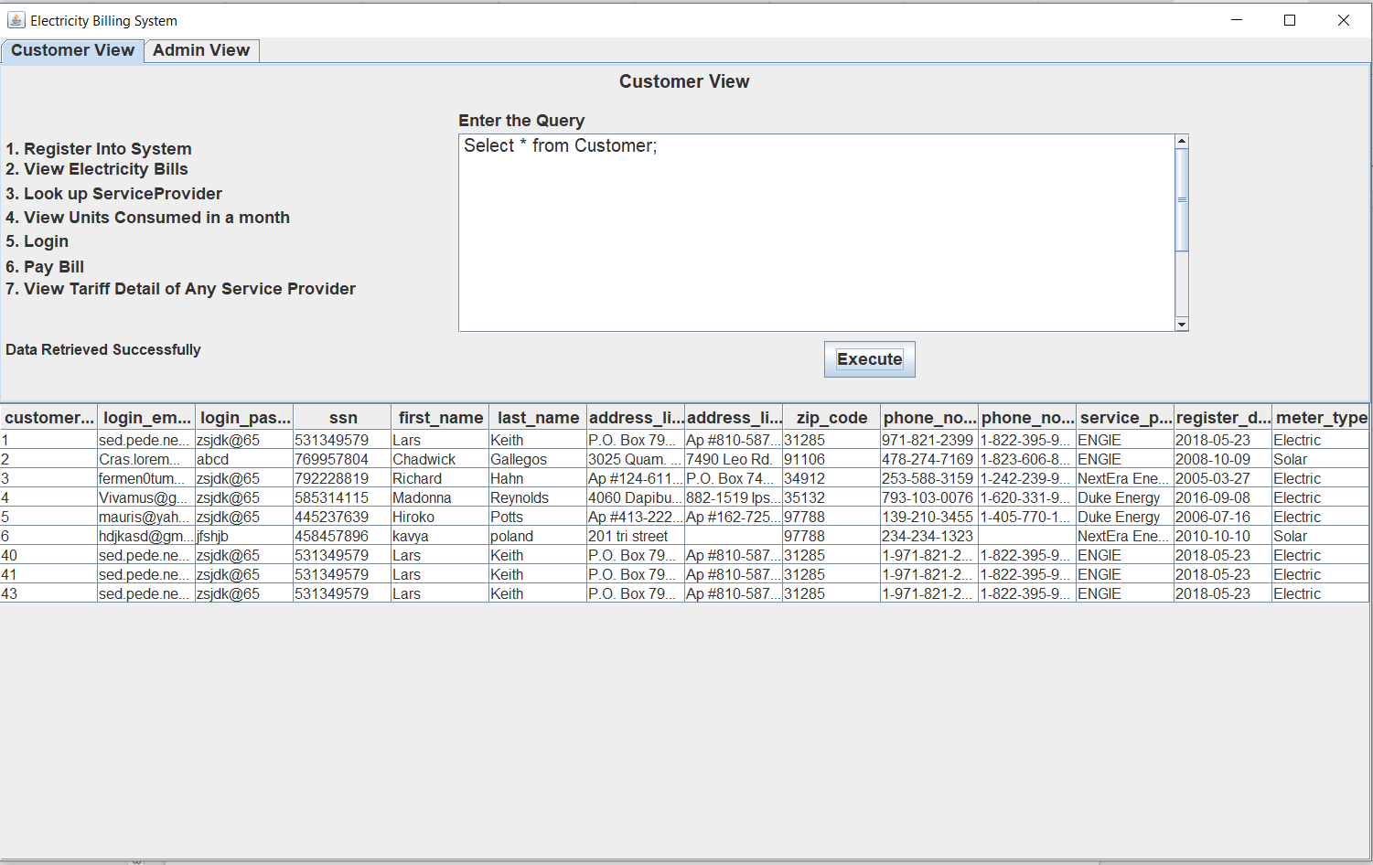

**After insertion:**

INSERT INTO Customer VALUES (44,'bb.smith@gmail.com','bs@65','531349569','Bob','Smith',

'P.O. Box 795, 3438 Consectetuer Street','Ap #810-587 Odio. St.',

'31285','1-971-821-239','1-822-395-977','ENGIE','2018-11-11','Solar');

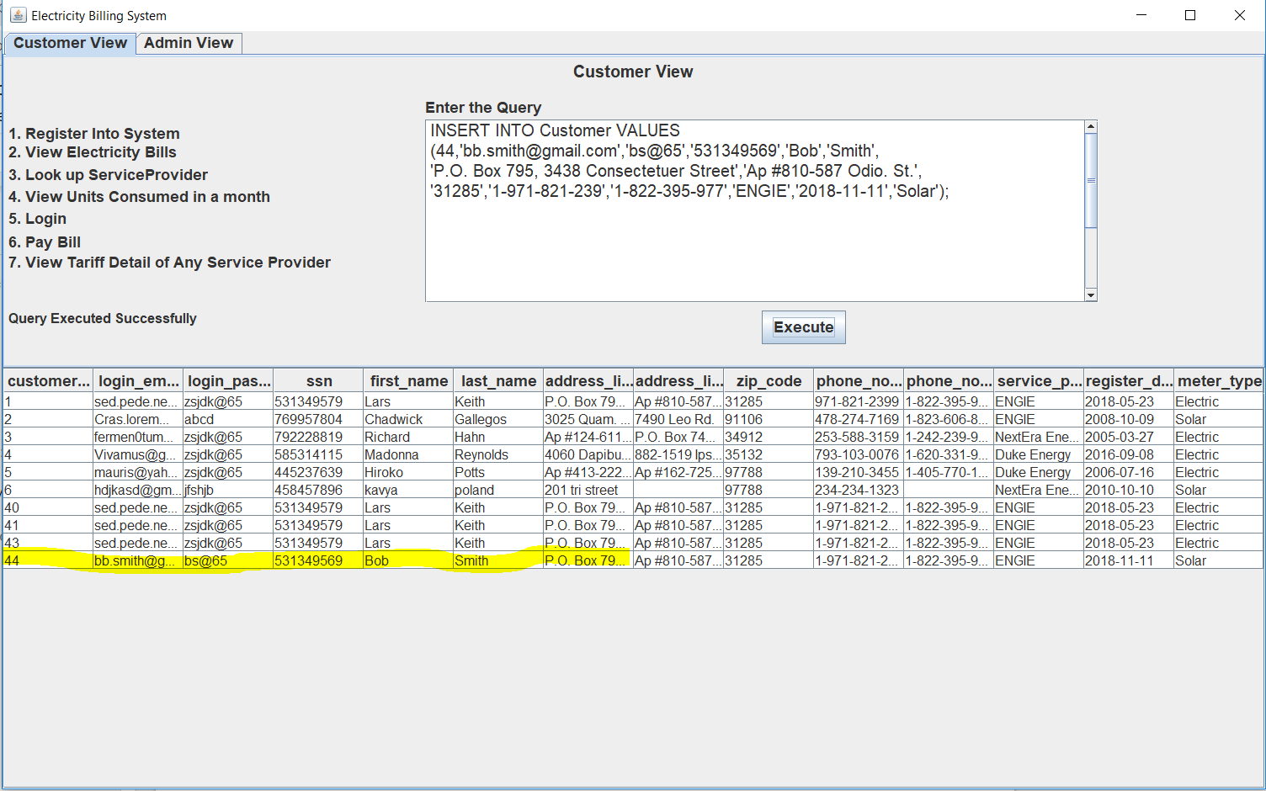

**2. Customer changes Service Provider.**

**Before:** Here customer_id we are taking is 43**.**

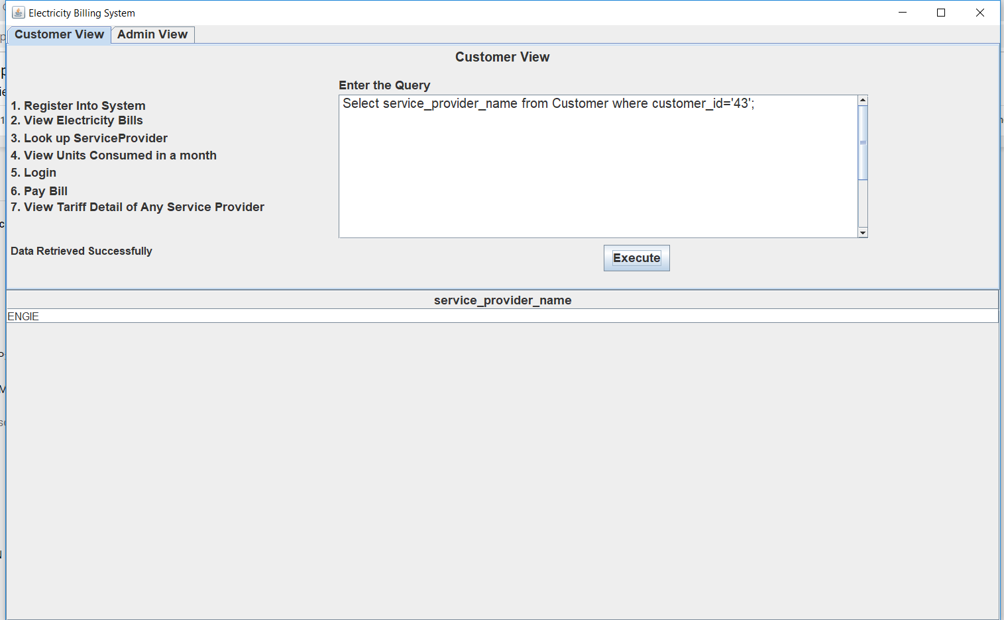

**After updating:**

update Customer set service_provider_name='Duke Energy' where customer_id='43'**;**

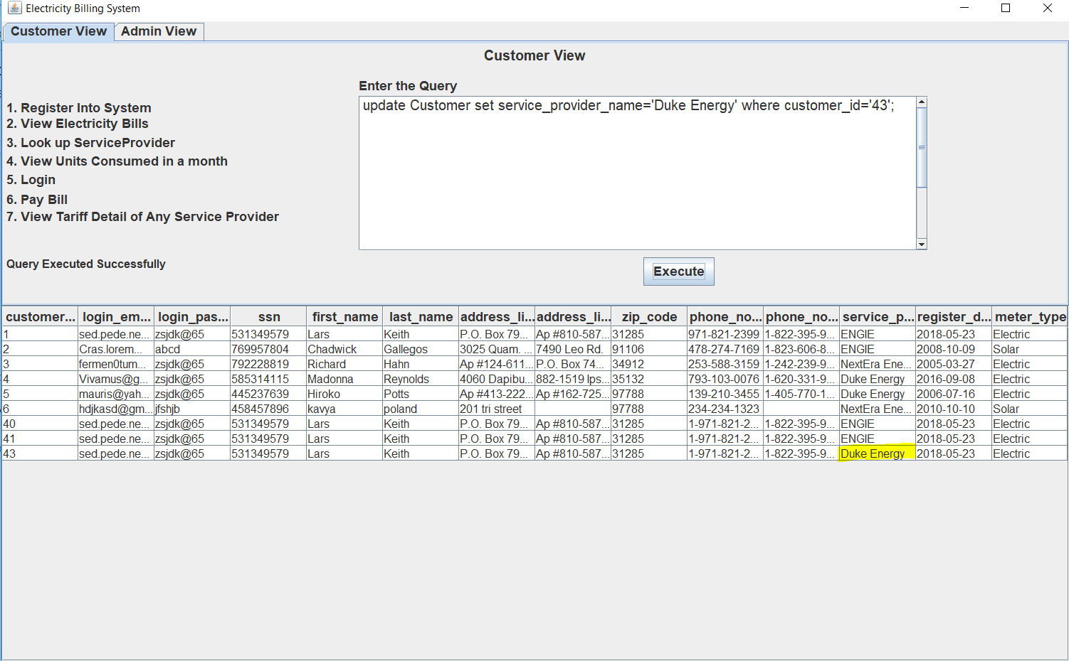

**3. Look up Service Providers available;**

Select * from Service_Provider;

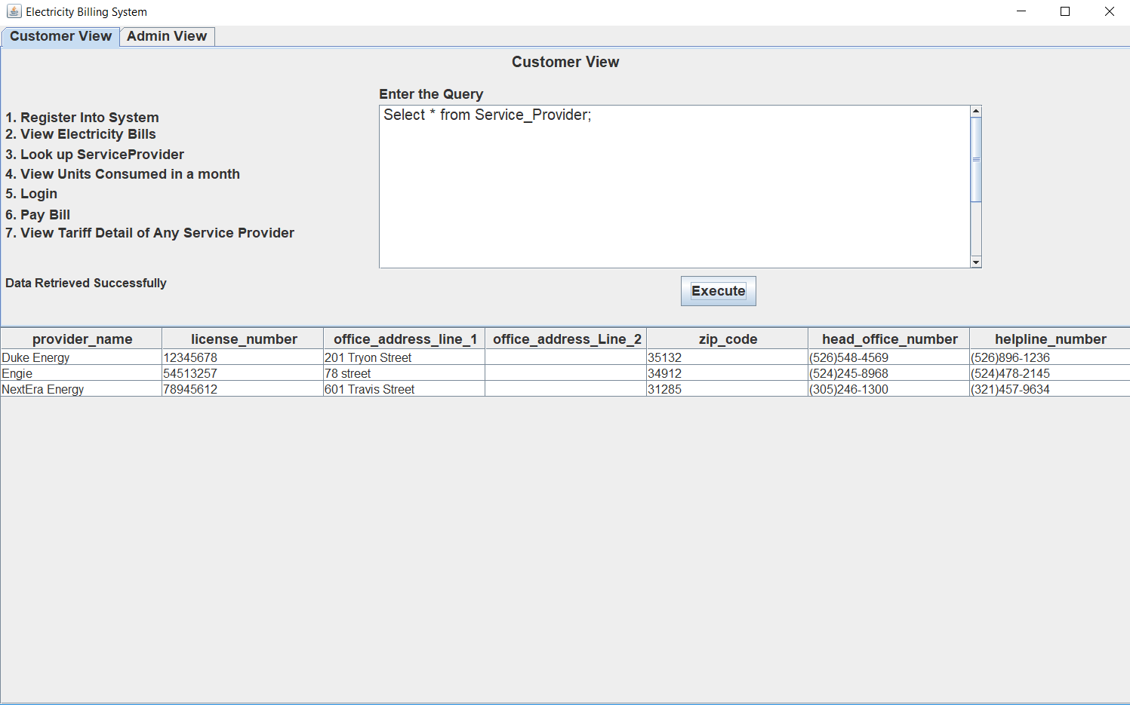

4. **Customer can view Tariff_Details of any Service Provider of any specific area.**

Select * from Tariff_Details where provider_name='Duke Energy' and zip_code='97788';

